Creating a Physics graph

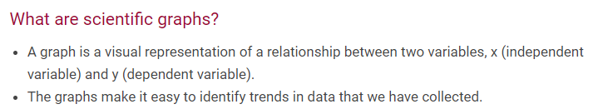
- Collect your data. After you have it all in one place, you should have one independent variable (like time) and one dependent variable (like something you measure as a function of time). Here are some points we will use as an example; we've measured position of a ball as a function of time:
Place your independent variable on the x axis and your dependent value on the y axis.
time (s) position (cm)
1 3.0
2 3.4
3 4.8
4 5.0
5 5.3
- Determine the range of your data. In order to determine how big a graph to make, we need to determine how much the numbers vary. In this case, time varies from 1 to 5 seconds, and position varies from 3.0 to 5.3 cm. We have to make sure that there is enough space on the graph to fit all the data. NOTE THAT YOU DO NOT HAVE TO USE THE WHOLE SHEET OF PAPER FOR YOUR GRAPH! It's perfectly acceptable to use only part of the page. The independent variable (time, in this case) will go on the x-axis (the one parallel to the bottom of the page), and the dependent variable (position, in this case) will go on the y-axis (parallel to the left hand side of the page). So, draw axes that are big enough for all the data. (see example.)

- Label your graph and your axes. THIS IS VERY IMPORTANT! When presented with your graph, other people should be able to figure out what is plotted without asking you.

- Titles of graphs are usually "Y versus X"; so in this case, our title is "Position versus Time." (NOT position divided by time, or position minus time.)

- Labels on the axes must have units! So, in this case, the label on the x axis (the one on the bottom) should be "Time (seconds)" and the label on the y axis (the one on the left) should be "Position (centimeters)."
Remember to write the numbers on the graph, too. The numbers should be evenly and logically spaced - what I mean by this is the following: for our position data here, the y-axis should be marked off in increments like (1,2,3,4,5,6) or (2,4,6,8), NOT (1.3, 2.6, 4.8,...) or anything else weird.

- Plot your data. Now, go ahead and place your data points on the graph. Make them big enough to be seen, but not big enough to look like you were eating pizza while making your graph.

- Draw a "line of best fit." THIS DOES NOT MEAN CONNECT THE DOTS! Only rarely will a graph need to have the data points connected by a jagged line. Usually, it is best to guess at a (straight) line that goes as near as possible to as many points as possible. (See example.) THE ORIGIN IS NOT ALWAYS INCLUDED AS A POINT! And, sometimes there will be a LOT of scatter and it might not be clear where a line should go.

Now you're done with your graph, but you're not finished yet.
Interpreting your graph

Think about what your graph means. The slope of the line that you drew describes how fast your line rises (or falls). To find the slope of your line, pick two points on the line, as far apart as possible. These two points are described as (x1,y1) and (x2, y2). In our example, two points our line intersects are (x1,y1) = (1, 2.8) and (x2, y2)=(4, 5). The slope of the line is given by (y2-y1)/(x2-x1), which here is (5-2.8)/(4-1) = 2.2/3 = 0.73
What do you think the units of the slope are? In this case, y's have units of cm, and x's have units of seconds. So, the units of the slope are cm/s, or in this case, 0.73 centimeters per second (cm/s). So for every second that we were watching it, the ball moved about 0.73 centimeters.

Example graph
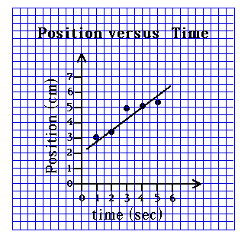

Summary
